Validation Testing:
1st time HTML Validation

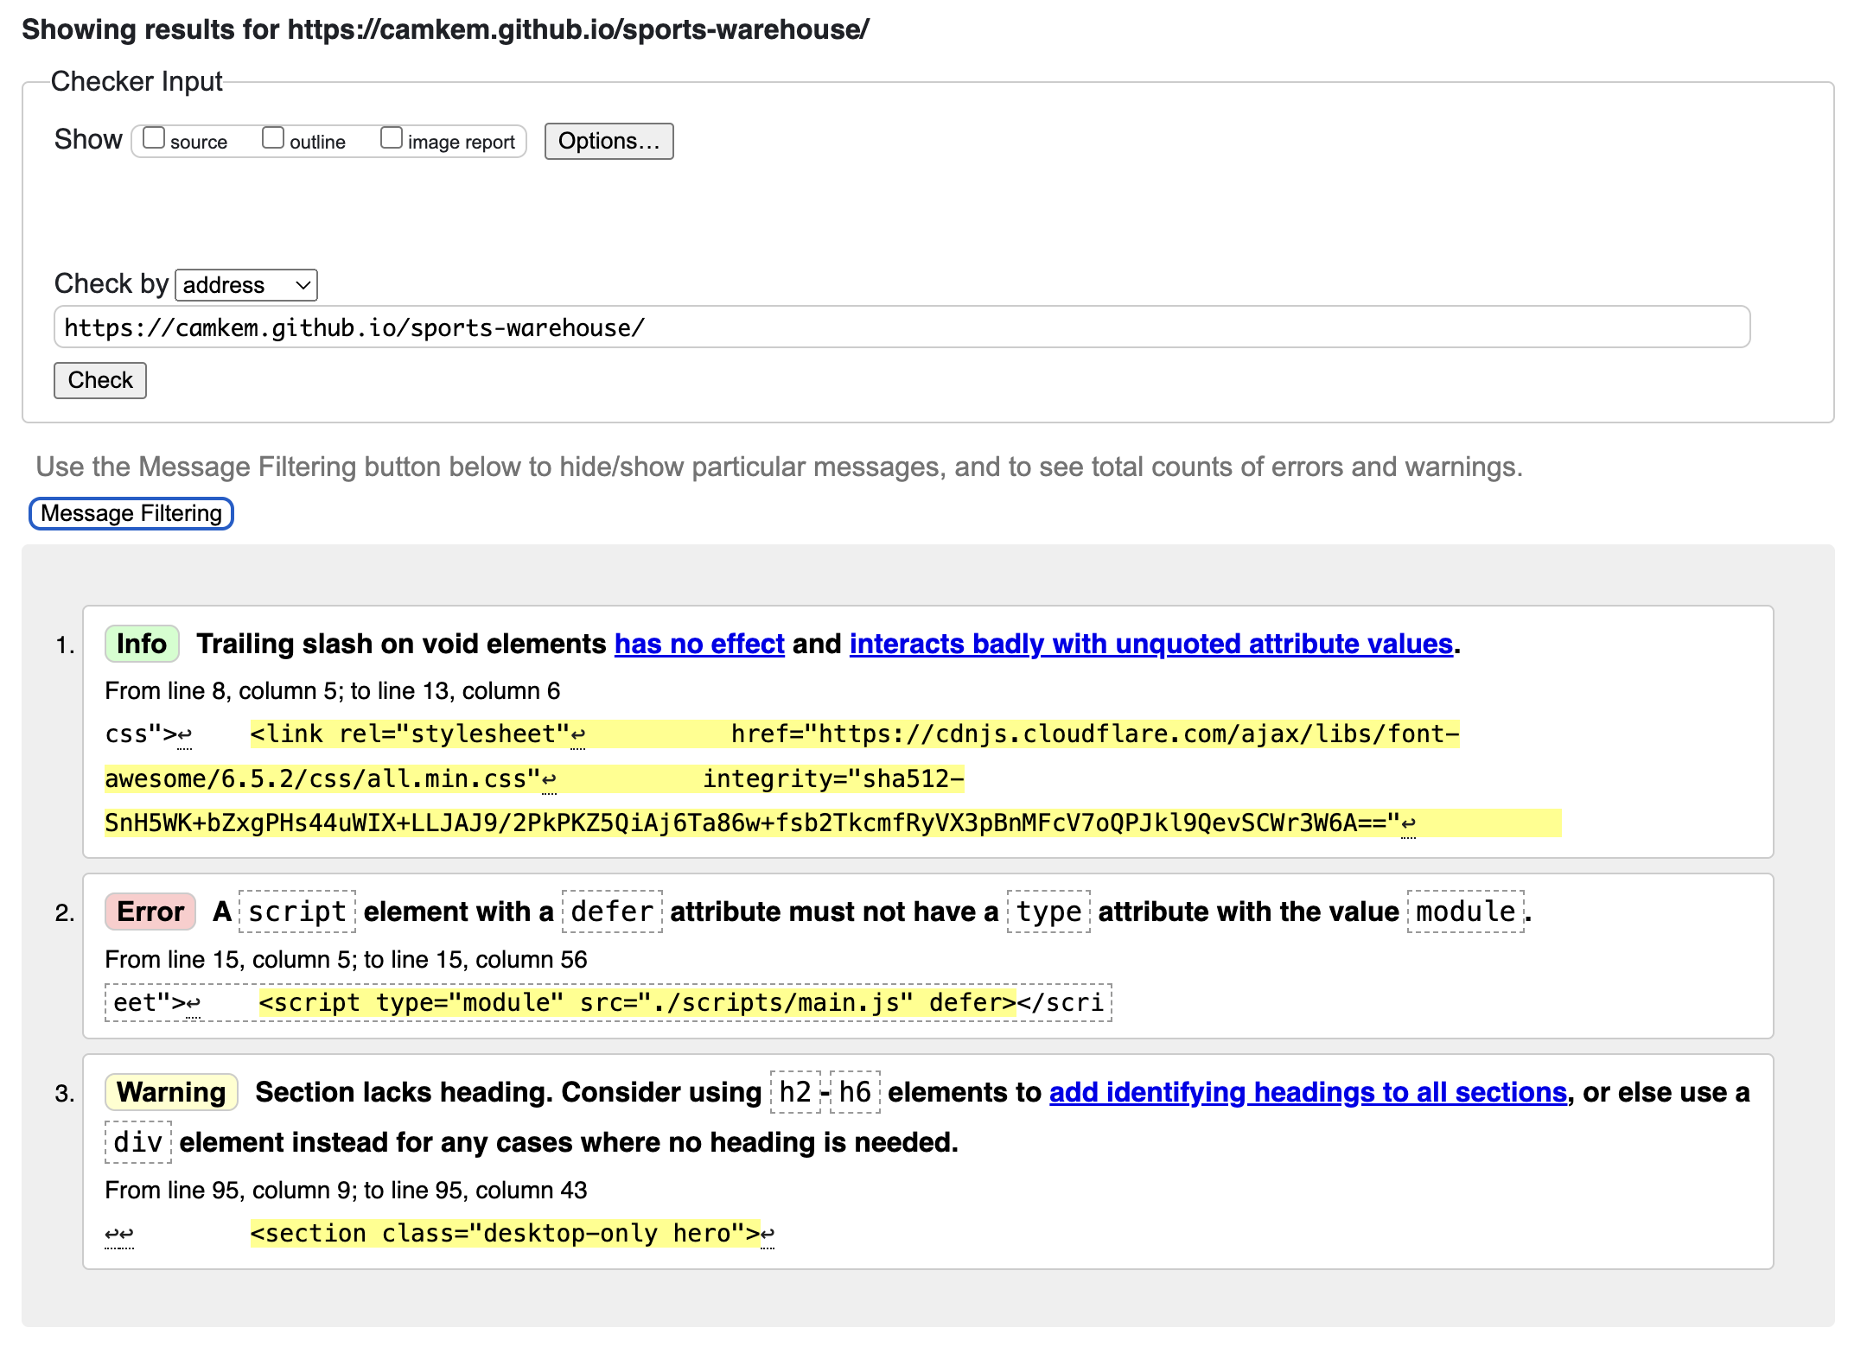
2nd time HTML Validation After Correcting the Errors

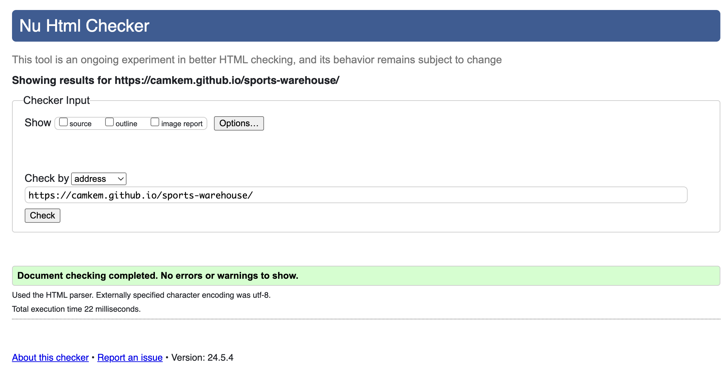

CSS Validation – Correct on the first try (All warning pertain the font-awesome style sheet that was included in the browser)

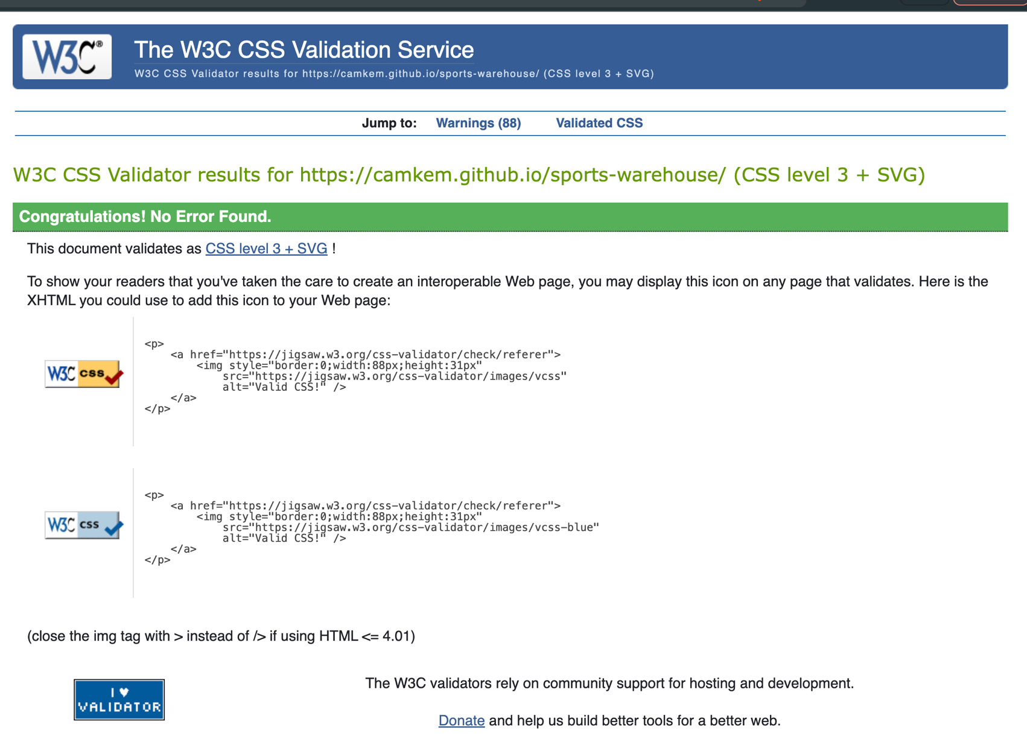

Browser Testing:
Safari Mobile | Chrome Mobile | Google Browser Mobile
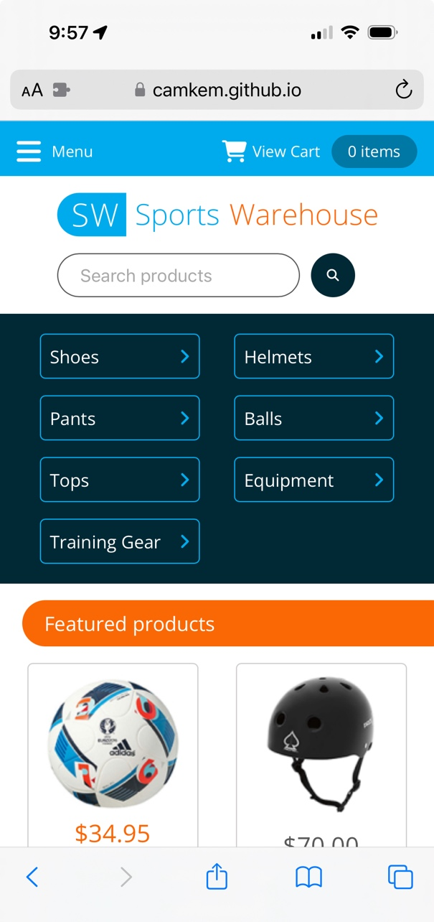 | 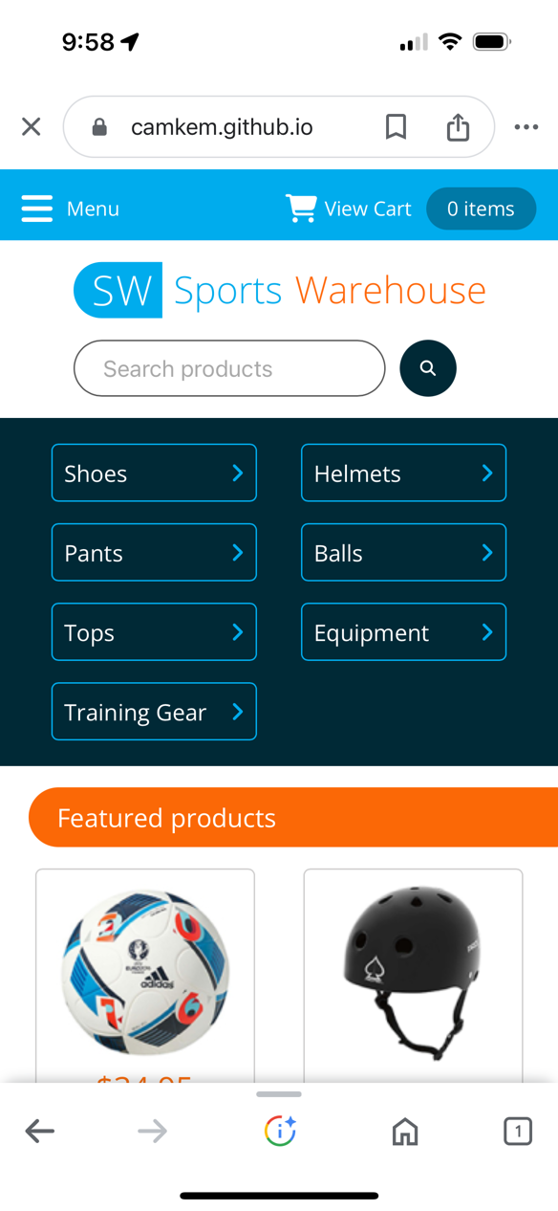 | 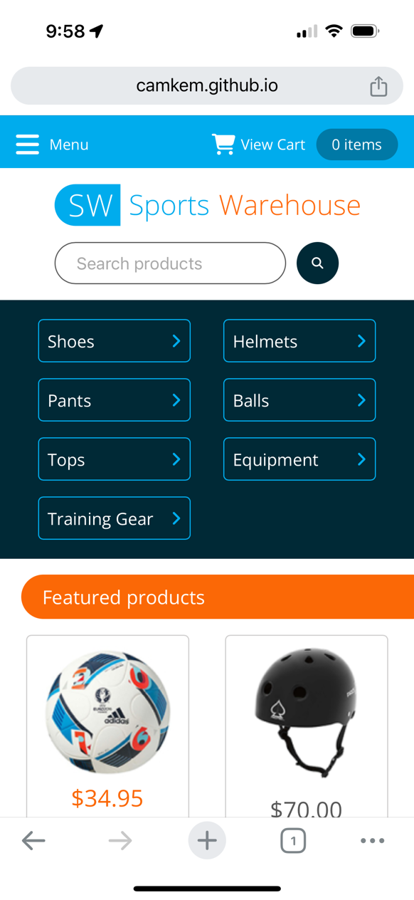

Edge Mobile | Firefox Mobile | Brave Browser Mobile
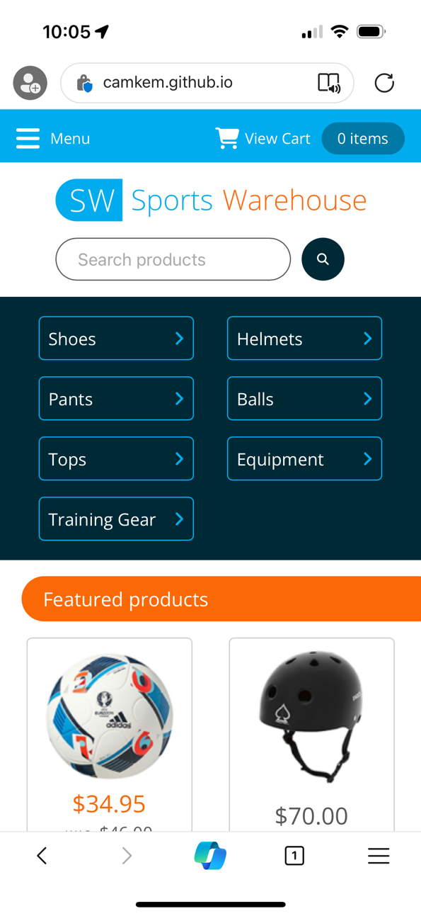 | 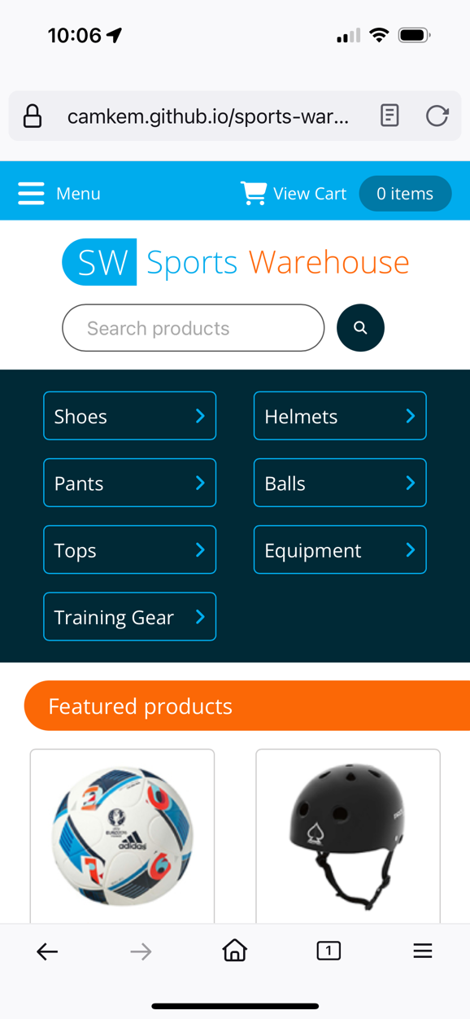 | 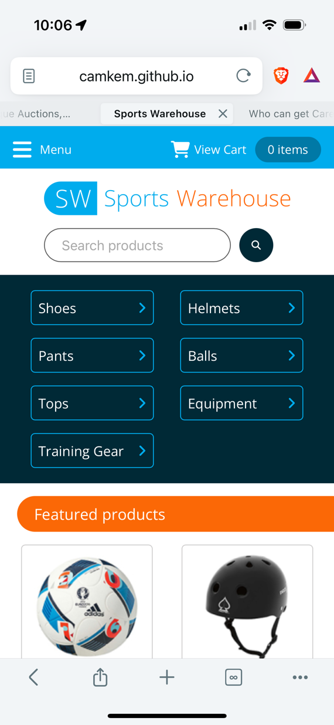

Firefox MacOs | Safari MacOs
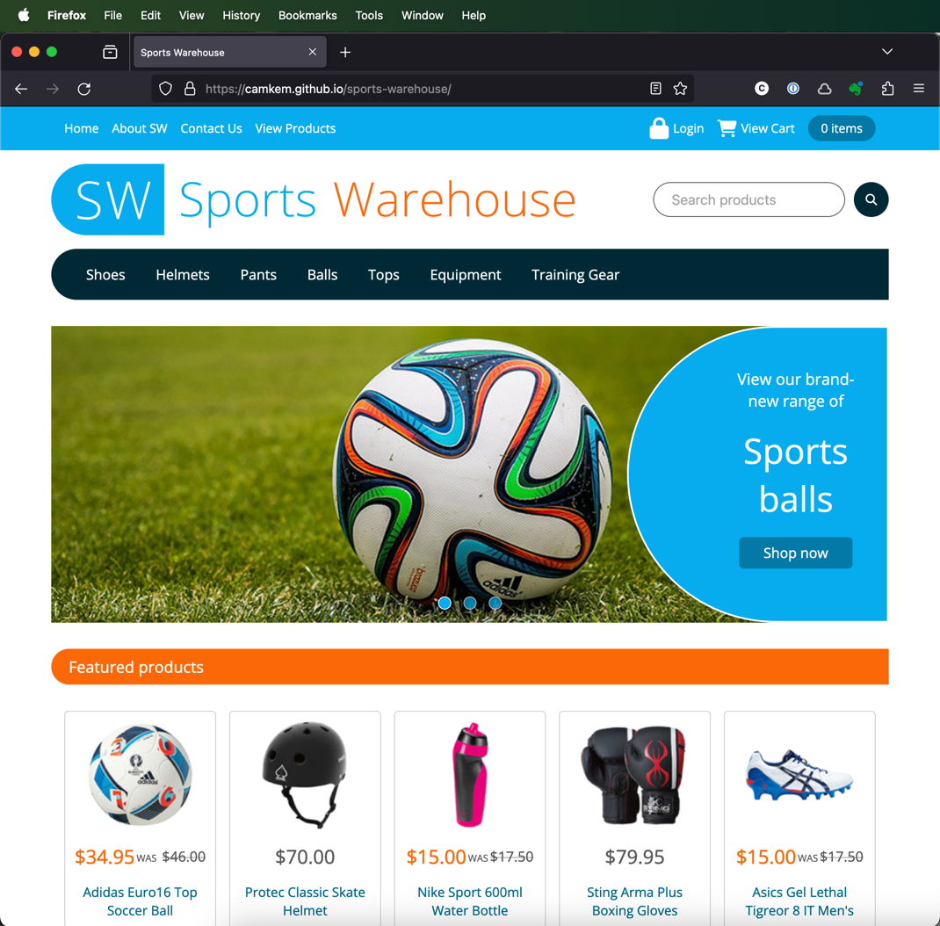 | 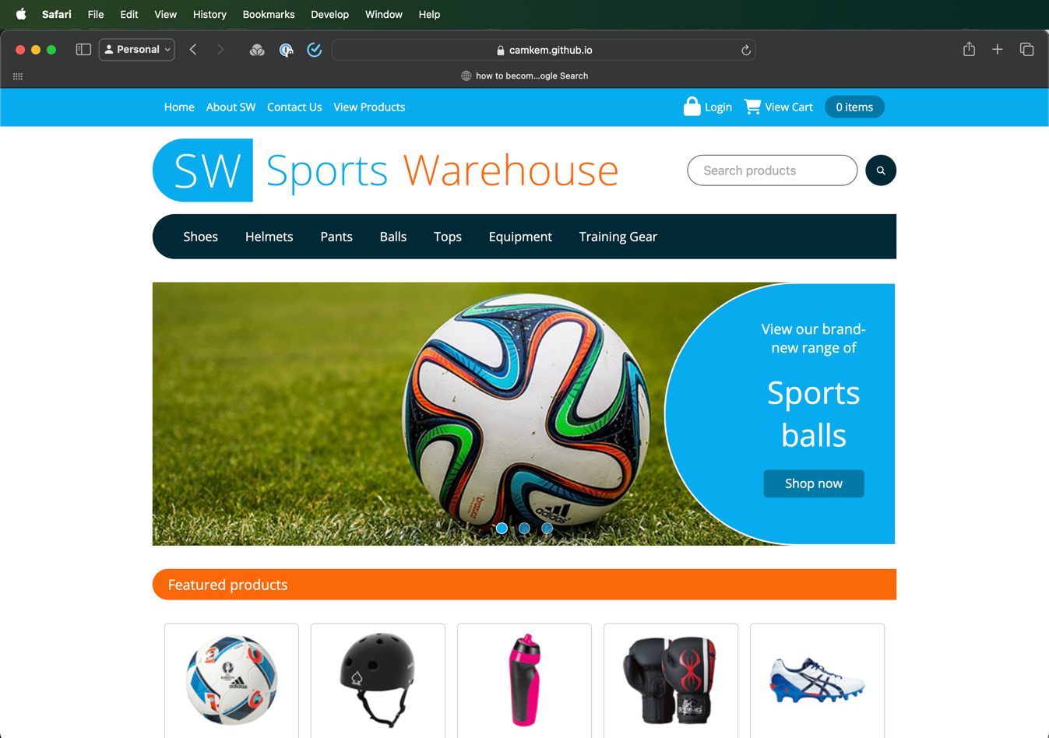

I had excellent consistency across all browsers & all devices used to test the website once it had been deployed to the production environment. There was no discernible differences between the different browsers across the 2 devices I tested on, which was pleasing to see.

Accessibility Testing:
I used https://www.accessibilitychecker.org/ which uses the WCAG 2.1 to test the accessibility of the website. There was 3 issues.

Firstly I didn’t have a valid accessible name on the search button, which I later added name=”website search button” attribute which solved the issue. The second issue was related to the design of the website, which is the contrast of 17 elements did not have a sufficient foreground/background contrast ration to allow vision impaired people to be able to clearly discern the content.
Third issue was related to having aria label on all the links, so I added aria label to each of the links for the website.

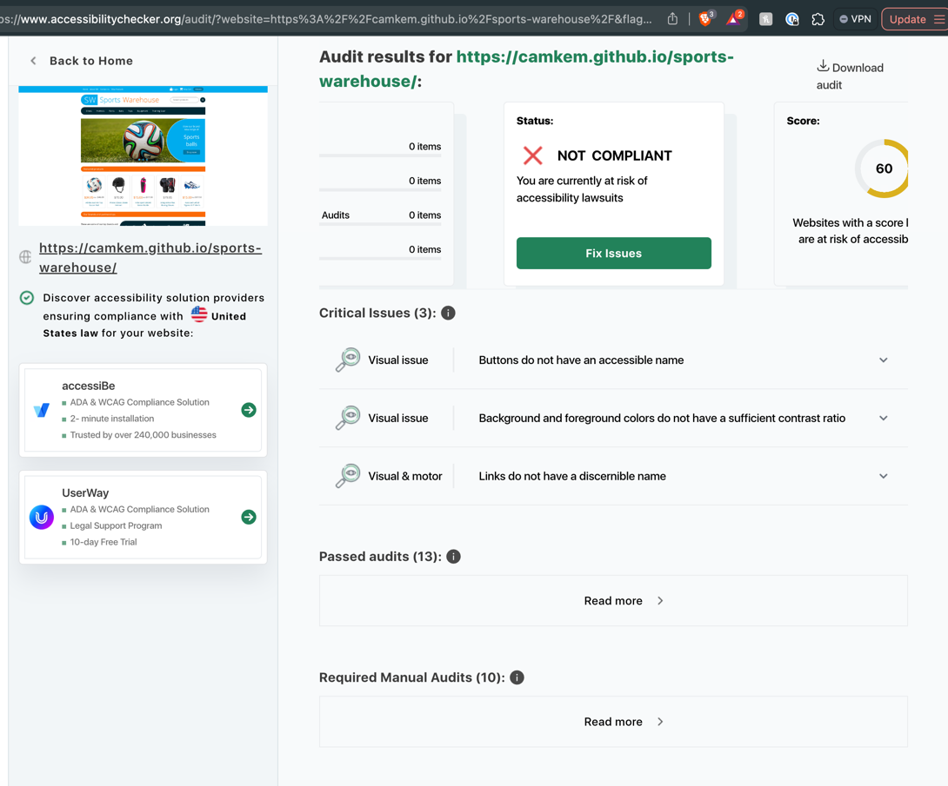 | Hypothetically, if a website is not navigable by keyboard, it can be inaccessible to users who cannot use a mouse.  This can be addressed by ensuring all interactive elements are focusable and can be activated using keyboard events.  Additionally, complex animations or auto-playing media can be problematic for users with cognitive disabilities or those who are susceptible to seizures.  Providing options to pause, stop, or hide such animations can help mitigate this issue.

I created a GitHub Pages project to serve this deliverable, which stores the assets & project files in a GitHub repository and can be found by visiting https://camkem.github.io/sports-warehouse/

